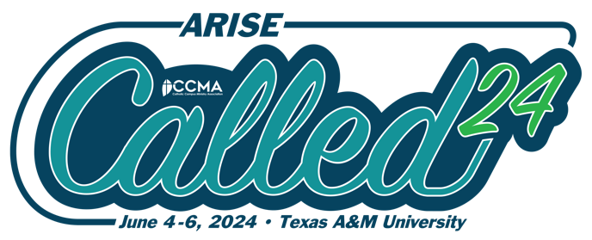
CALLED24 National Conference
Sponsored by CCMA
CALLED24 is the best return-on-investment out there for professional development for campus ministry professionals and chaplains. Great for new campus ministers or seasoned veterans looking for proven strategies, tactics and an authentic experience of community.
FAQ
What if we just hired new campus ministers on our team or in our Diocese?
CALLED24 is the perfect way to jumpstart your new team members. Three days of intensive training and community gives your new campus ministry professionals the tools they need to thrive in campus ministry.
How will this benefit the campus/Diocese/ministry that I work for?
Conference attendees will experience and benefit from:
- Time away from the hustle and bustle of campus life so that you can be alone with the Lord in prayer and yet together with your peers in ministry
- Tools & techniques to increase outreach to disaffiliated students
- Confidence to continue to grow as a campus ministry professional
- Inspiration and support to thrive within the difficult work of campus ministry
- Access to vendors and organizations that can support your ministry
- Case Studies with meaningful examples and takeaways you can implement on your campus
- Teambuilding & development to ensure the collaboration needed to meet your ministry goals
- Network in-person with similar individuals and organizations
- Opportunity to discuss problems and challenges that you are facing with your peers allowing creative problem-solving and impactful brainstorming
- Establish future partnership/ministry opportunities resulting from authentic conversations and connections

Sample Justification Letter
Dear [Supervisor’s Name],
I was recently researching professional development opportunities and I came across the
CALLED24 national conference, hosted by the Catholic Campus Ministry Association, held in College Station Texas at Texas A&M University from June 4-6th, 2024. Based on my research, CCMA is a leading voice for campus ministry professionals.
CALLED24 brings together development professionals from across the nation to address concerns, share ideas and activities that will be beneficial to [our organization]. The conference offers effective strategies, best practices, and tools via presentations, discussions and networking with development professionals and campus ministry leaders.
Here’s how my attendance will be a positive return on investment for our [organization]:
- I’ll learn how to establish and improve current campus ministry program
- I’ll have the chance to engage in deeper discussions with my peers about how to effectively address the reality of students who are disaffiliated from the Catholic faith
- I’ll gain confidence in a clear strategy forward for our ministry
- I’ll learn how to better share the Gospel with my entire campus community

Here’s the cost breakdown of sending me to CALLED24:
 | Member Rate | Non-Member Rate
Early Bird Registration  Ends March 5th | $499 | $549
Early Registration  Ends April 15th | $550 | $600
Registration  Ends May 14th | $650 | $700
Full Price Registration  Ends June 3rd | $700 | $750
*Special discounts for teams of two or more
- Hotel: $417 (3 nights stay @ $139 per night) +tax
- Meals Included:
- Coffee bar each morning
- Lunch Wednesday and Thursday
- Sit down banquet style dinner, Wednesday evening

This is a good investment of time and resources that will deliver real value to our organization. Thank you for your consideration.
Sincerely,
[signed]

