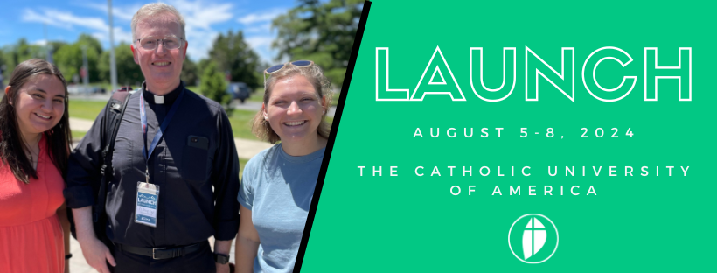
LAUNCH: 1-5th Year Campus Ministry Training
Sponsored by CCMA
LAUNCH24 is the only program of its kind designed to equip and empower new campus ministry professionals to evangelize on campus. Participants will learn from veteran staff who share tried and true strategies and data that can be creatively applied to any college campus ministry in the country.
FAQ
What if we just hired new campus ministers on our team or in our Diocese?
If those new hires are just starting out in campus ministry, LAUNCH is the perfect opportunity for them. LAUNCH is also ideal those transitioning from being a campus missionary (with FOCUS, SPO or Evangelical Catholic or other organizations), youth minister or other career/ministry fields to campus ministry. Many participants begin their first week of work at LAUNCH, giving them an incredible orientation to campus ministry.
How will this benefit the campus/Diocese/ministry that I work for?
LAUNCH attendees will experience and benefit from:
- Time away from the hustle and bustle of campus life so you can pray and be renewed in your spiritual life
- A foundation in campus ministry – the theology, pastoral ministry and practical skills needed to evangelize and share the Gospel on campus today
- Inspiration and support to thrive within the difficult work of campus ministry
- Case Studies with meaningful examples and takeaways you can implement on your campus
- Building your peer network
- Opportunity to discuss problems and challenges that you are facing with your peers allowing creative problem-solving and impactful brainstorming
- Establish future partnership/ministry opportunities resulting from authentic conversations and connections
How is CALLED24 different from LAUNCH?
Both CALLED24 and LAUNCH are professional development events that will benefit anyone working in campus ministry. The LAUNCH curriculum provides a step by step foundation for campus ministry. New hires through people in their fifth year in campus ministry will benefit most from attending LAUNCH. We encourage that campus ministry professionals attend LAUNCH once, at the start of their career.
CALLED24 provides a broader scope of professional development. The theme and workshops change year to year based on the current trends and needs of campus ministry. We encourage campus ministry professionals to attend CALLED yearly for renewal, inspiration and networking.

Sample Justification Letter
Dear [Supervisor’s Name],
I was recently researching professional development opportunities and I came across the LAUNCH Campus Ministry Training, hosted by the Catholic Campus Ministry Association, held in Washington, D.C. at The Catholic University of America from August 5-8, 2024. Based on my research, CCMA is a leading voice for campus ministry professionals in the country.

LAUNCH offers a foundation in campus ministry – the theology, pastoral ministry and practical skills needed to evangelize and share the Gospel on campus today. I will learn from veteran campus ministry professionals who share tried and true strategies and data that can be creatively applied to [our organization].

Here’s how my attendance will be a positive return on investment for our [organization]:

- I study Church documents on Campus Ministry and Evangelization and be able to articulate a vision for our campus ministry
- I will receive training in the pastoral and practical skills needed to minister to students on campus today
- I will build a plan for ministry growth for our campus
- I will grow my professional network

Here’s the cost breakdown of sending me to LAUNCH:
LAUNCH costs CCMA $900 per attendee. Thanks to our generous donors, we can offer every attendee a scholarship that reduces the cost to $600-$650 per person as shown below.
 | Cost to you | Scholarship savings
Early Bird Registration – includes meals, on campus lodging, meals, resource binder and digital resources.  Ends April 31 | $600 | $300
Registration - includes meals, on campus lodging, meals, resource binder and digital resources.  Ends July 1, 2024 | $650 | $250
Travel costs | [update] | -
*Special $25 discount per attendee for Diocese/teams sending 2+ campus ministry professionals to LAUNCH.
- Meals Included:
- Dinner on August 5
- Breakfast, Lunch and Dinner on August 6 and 7
- Breakfast on August 8

This is a good investment of time and resources that will deliver real value to our organization. Thank you for your consideration. If you have any questions about LAUNCH, or wish to receive the $25 discount code, please email Lisa Lytwyn, LAUNCH Coordinator, at lytwyn@ccmanetowrk.org.
Sincerely,
[signed]

