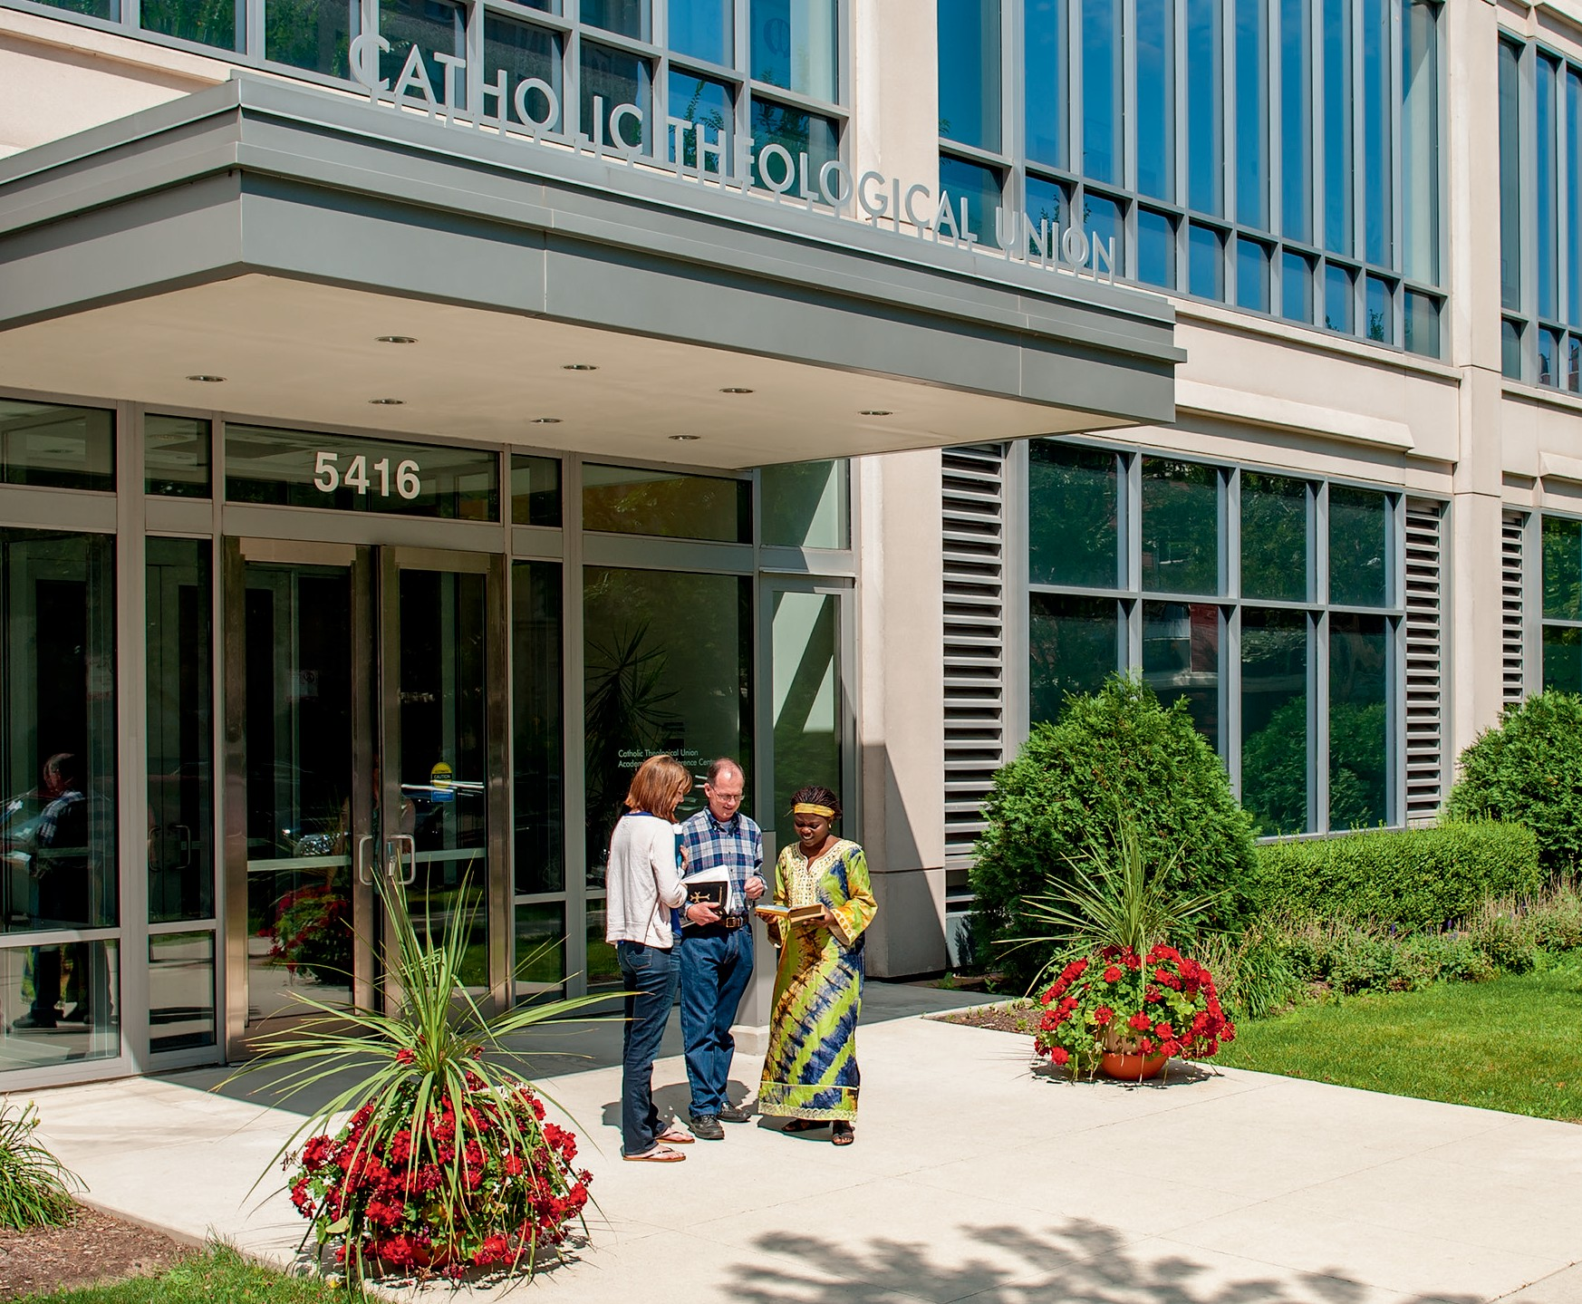SUMMER INSTITUTE 2017

Share a Great Summer at CTU

SUMMER INSTITUTE

COME STUDY WITH US AT
CATHOLIC THEOLOGICAL UNION’S SUMMER INSTITUTE
Summer Institute participants have the opportunity to study with CTU’s renowned faculty on campus in Chicago or online. With accreditation from the Association of Theological Schools (ATS), CTU offers the highest quality theological preparation and formation for people of varying needs and interests. Courses may be audited, taken for Continuing Education Units (CEUs), or taken for credit after a short admissions process. Blended (online and on campus) classes are also available.

RETURNING TO CHICAGO OR VISITING FOR THE FIRST TIME?
Continue your learning in the great city of Chicago, which is home to world-class museums, music venues, theaters, professional sports teams, outdoor festivals, endless bike paths, and world-renowned architecture.
For class descriptions and more information, visit www.ctu.edu/summer-institute
or contact Sallie Latkovich, CSJ, at 773.371.5436 or slatkovich@ctu.edu.

DISTANCE LEARNING

ONLINE COURSE JUNE 1 – JULY 15
P2300S Philosophical Ethics (3 credits)
Herman Stark, PhD, Adjunct Professor of Philosophy, CTU

COURSES WEEK ONE: JUNE 5 – 9
DC4100S Trinity and Mission (3 credits)
First week (June 5-9) is online, the second week (June 12-16) will be on campus.
Br. Antonio Sison, CPpS, PhD, Associate Professor of Systematic Theology, CTU

MORNING: 9 – 11:30 A.M.
G3001S Immigration: The Law and the Experience (1 to 3 credits)
Sr. Bernadine Karge, OP, JD, Chicago Immigration Attorney

W4019S Canonical Issues in Pastoral Ministry (1 credit)
Msgr. Patrick Lagges, JCD, PhD, Adjunct Professor of Canon Law, CTU

AFTERNOON: 1 – 3:30 P.M.
B4026S Pentateuch (1 to 3 credits)
Fr. James Okoye, CSSp, DPhil, Director of Center for Spiritan Studies, Duquesne University
E4006S Feminist Ethics (3 credits)
Required reading assignments begin online May 21
Patricia Beattie Jung, PhD, Visiting Professor of Christian Ethics, Loyola University
C4013S Interculturalism: A Response to God’s Love (1 to 3 credits)
Fr. Rudy Vela, SM, DMin, St. Mary’s University

EVENING: 6:30 – 9 P.M.
W4020S The Revised Rite of Marriage (1 to 3 credits)
Fr. Richard Fragomeni, PhD, Professor of Liturgy and Preaching, CTU; Rector, Shrine of Our Lady of Pompeii
B4031S The Gospel of Mark (1 to 3 credits)
Fr. Donald Senior, CP, STD, President Emeritus, Chancellor, Professor of New Testament Studies, CTU

COURSES WEEK TWO: JUNE 12 – 16

MORNING: 9 – 11:30 A.M.
B4037S The Letter to the Romans: Paul’s Lasting Legacy (1 to 3 credits)
Sr. Carolyn Osiek, RSCJ, PhD, Provincial Archivist, Society of the Sacred Heart

C4014SA Introduction to Black Church Studies (first of two weeks) (3 credits)
Diana Hayes, JD, PhD, STD Professor Emerita, Georgetown University

W4033S Singing the Threshold: Music and the RCIA (1 credit)
Jennifer Budziak, DMA, Director of Music, Old St. Patrick’s Church (Chicago)
W4205C Lay Leadership of Prayer and Preaching (1 credit) Prerequisite W4205A & W4205B. Meets in morning and afternoon
Eileen Crowley, PhD, Associate Professor of Liturgy Arts and Communications, CTU

AFTERNOON: 1 – 3:30 P.M.
B4038S Isaiah (1 to 3 credits)
Sr. Luma Khudher, OP, PhD, Dominican Sisters of St. Catherine of Siena - Iraq
DC4100S Trinity and Mission (3 credits)
First week (June 5-9) is online, the second week (June 12-16) will be on campus.
Br. Antonio Sison, CPpS, PhD, Associate Professor of Systematic Theology, CTU

C4014S Islam and Muslims in a Time of Islamophobia: A (Catholic) Christian Response (1 to 3 credits)
Scott Alexander, PhD, Associate Professor of Islamic Studies, Director of Catholic-Muslim Studies Program, CTU

EVENING: 6:30 – 9 P.M.
B4039S Bible for Ministry (1 credit)
Sallie Latkovich, CSJ, DMin, Director, Biblical Study and Travel Program and Summer Institute, CTU
G3002S Wise and Holy Women and a Few Good Men (1 to 3 credits)
Br. Mickey McGrath, OSFS, visual artist, author
W4030s The Anointing of the Sick (1 credit)
Fr. Richard Fragomeni, PhD, Professor of Liturgy and Preaching, CTU; Rector, Shrine of Our Lady of Pompeii
BC4001S Jewish-Christian Dialogue* (1 to 3 credits)
*Note: This class will meet from Monday to Thursday, 6 to 9 p.m. No Friday class.
Malka Simkovich, PhD, Visiting Assistant Professor in Jewish Studies, CTU

COURSES WEEK THREE JUNE 19 – 23

MORNING: 9 – 11:30 A.M.
B4040S Faith and Grace in the Letter to the Galatians (1 to 3 credits)
Fr. Ferdinand Okorie, CMF, PhD cand., lecturer, Loyola University

C4015S At the Intersection of Race and Culture: Living Faith in Latino/a and Latin American Contexts (1 to 3 credits)
Néstor Medina, PhD, lecturer, Toronto School of Theology

C4014SB Introduction to Black Church Studies (second of two weeks) (3 credits)
Diana Hayes, JD, PhD, STD, Professor Emerita, Georgetown University
FP4001S Theology of Ministry (1 to 3 credits)
Fr. Thomas O’Meara, OP, PhD, Professor Emeritus, University of Notre Dame

W4034S Building Effective and Engaging Religious Education in Parishes and Schools
(1 to 3 credits)
Sr. Mary Paul McCaughey, OP, Former Superintendent of Catholic Schools
for Archdiocese of Chicago and Instructional Assistant Faculty, DePaul University

AFTERNOON: 1 – 3:30 P.M.
C4016S Black Catholic Lay Movements (1 to 3 credits)
Cecilia Moore, PhD, Associate Professor, Dayton University
D5101S God and the Mystery of Suffering (1 to 3 credits)
Fr. Robin Ryan, CP, PhD, Associate Professor of Systematic Theology, CTU
C4017S Asian American Catholics and Racism (1 to 3 credits)
Fr. Linh Hoang, OFM, PhD, Associate Professor of Religious Studies, Siena College
D4011S Rahner on Spirituality (1 to 3 credits)
Fr. James Bacik, DPhil, Adjunct Professor of Humanities, University of Toledo
S4021S Friendship and the Christian Tradition (1 to 3 credits)
Donna Orsuto, STD, Co-Founder and Director of the Lay Centre at Foyer Unitas (Rome)

EVENING: 6:30 – 9 P.M.
S4027S Spirituality of Thomas Merton for Today: On Racism, Violence and Justice
(1 to 3 credits)
Fr. Daniel P. Horan, OFM, PhD, Visiting Assistant Professor of Systematic Theology, CTU
MP4017S Global Leadership in Campus Ministry (1 to 3 credits)
Fr. Eddie DeLeón, CMF, DMin, Assistant Professor of Pastoral Ministry and Director of Intercultural Outreach, CTU

Register early! Courses are subject to change.
Courses with fewer than five students registered as of May 25, 2017, will be cancelled.

REGISTRATION FOR SUMMER INSTITUTE 2017
Register online at www.ctu.edu/summer-institute. Students can also register by sending an email with course selections to registrar@ctu.edu, or by mailing a printed list of course selections to Office of the Registrar, Catholic Theological Union, 5401 S. Cornell Ave., Chicago, IL 60615.
Note for current degree-seeking students: Please use the current online registration process, or the CTU Registration Form found in the Registrar’s Office.
Note for visiting students: If you are enrolled at another institution and wish to transfer credit into that program, we ask you to 1) fill out and submit the online short-form application for admission, and 2) submit a letter to the CTU Admissions Office from your current school’s Registrar’s Office confirming that you are enrolled and in good standing, academically and financially. Please see http://www.ctu.edu/admissions/visiting-students to access the application. Questions? Email the Office of Recruitment at recruit@ctu.edu.

FEES
Summer registration fee . . . . . . . . . . . . . . . . . . . . . . . . . . . . . . . . . . . . . . . . . . . . . . . . .$50
Audit fee per course . . . . . . . . . . . . . . . . . . . . . . . . . . . . . . . . . . . . . . . . . . . . . . . . . . .$375
Graduate academic fee per credit-hour . . . . . . . . . . . . . . . . . . . . . . . . . . . . . . . . . . . .$855
Room and Board per week (Sunday through Saturday) . . . . . . . . . . . . . . . . . . . . . . . .$485 Room only per night . . . . . . . . . . . . . . . . . . . . . . . . . . . . . . . . . . . . . . . . . . . . . . . . . . . .$60
Parking per week . . . . . . . . . . . . . . . . . . . . . . . . . . . . . . . . . . . . . . . . . . . . . . . . . . . . . .$25

PAYMENT
Send checks to Catholic Theological Union, Attn: Business Office, 5401 S. Cornell Ave., Chicago, IL 60615.
For billing questions and to pay by credit card, call John Hayes in the Business Office at 773.371.5405.

ALUMNI ASSOCIATION DISCOUNT
Members of the Alumni Association receive a 25 percent discount on tuition for audited courses. If you are an alum and would like to join, contact the Alumni Office at alum@ctu.edu or 773.371.5410.

BOOKS
CTU does not have an on-site bookstore. After May 1, 2017, visit www.ctu.edu/academics/ ctu-virtual-bookstore for more information about ordering books online.

CREDITS
Unless otherwise noted, all Summer Institute courses are offered for one credit hour. If two or three credits are available, they are earned through additional readings and writing assignments appropriate to the additional credit hours. Assignments are ordinarily due by the end of August, unless otherwise noted by the professor. Those not seeking credit should register as an auditor.

Academic Credit for New and Visiting Students: If you are not currently enrolled at CTU or another institution, but would like to receive academic credit for your classes, please see our standard admissions guidelines and procedures at www.ctu.edu/apply. CTU accepts applications for degree and certificate programs and for continuing education students seeking academic credit during Summer Institute.
If you are enrolled at another institution and would like to receive academic credit for your classes, please see our admissions guidelines and procedures for visiting students at www.ctu.edu/apply/visiting-students. Questions? Email the Office of Recruitment at recruit@ctu.edu.
Auditors (non-credit students): May register for classes for enrichment or ongoing educa- tion. More than one audit hour may require additional fees.
Continuing Education Units: CEU students who wish to receive a certificate upon course completion will be assessed an additional $35. On the online registration form, please check the box indicating CEU credit and include the fee in your registration cost.

HOUSING AND PARKING INFORMATION
CTU offers accessible guest housing in our Residence Hall and Student Center
(5401 S. Cornell Ave.), located across the street from the Academic and Conference Center (5416 S. Cornell Ave.). The Residence hall houses a cafeteria and dining hall, student lounge, and residential rooms with private baths. Each room is air-conditioned and has a double bed, desk and chair, dresser, nightstand, and bookcase. A telephone and Wi-Fi access are also available, and residents have access to free laundry facilities, a kitchen, lounge, and chapel.
Summer Institute housing and enclosed garage parking are limited and assigned on a first-come-first-served basis. To request housing and/or parking register online at www.ctu.edu/summer-institute. You will be contacted about the status of your reservation after submitting your request.

ROOM AND BOARD
Please reserve room and board online at www.ctu.edu/summer-institute. Weekly package is $485. Questions? Contact the Student Services Office, 773.371.5402 or studentservices@ctu.edu.

PARKING
The parking garage is adjacent to 5416 S. Cornell Ave. To reserve parking, pay $25 per week. Reserve a spot online at www.ctu.edu/summer-institute. Questions? Contact Vickie Wilson, 773.371.5400 or receptionist@ctu.edu.

TRANSIT
For more information on getting to and from CTU within the city of Chicago, go to

www.ctu.edu/about/directions.

Like us on facebook! facebook.com/ChicagoCTU

5401 S. Cornell Ave. Chicago, Illinois 60615 www.ctu.edu 773.371.5400

Refresh your ministry, replenish your knowledge, renew your faith

